# CS 255 System Design Document Template

This template lays out all the different sections that you need to complete for Project Two. Each section has guidance to prompt your thinking. You will need to continually reference the interview transcript as you work to make sure that you are addressing your client’s needs. There is no required length for the final document. Instead the goal is to complete each section based on what your client’s needs are. Remove this note when you are finished, and replace all bracketed text with the relevant information.

## UML Diagrams

### UML Use Case Diagram

*[In Module Six, you were asked to complete a use case diagram based on your system design. If you would like to make any adjustments to your diagram, please do so. Please insert your use case diagram here. Check to make sure that you included appropriate components and symbols and that your design meets the client’s needs.]*

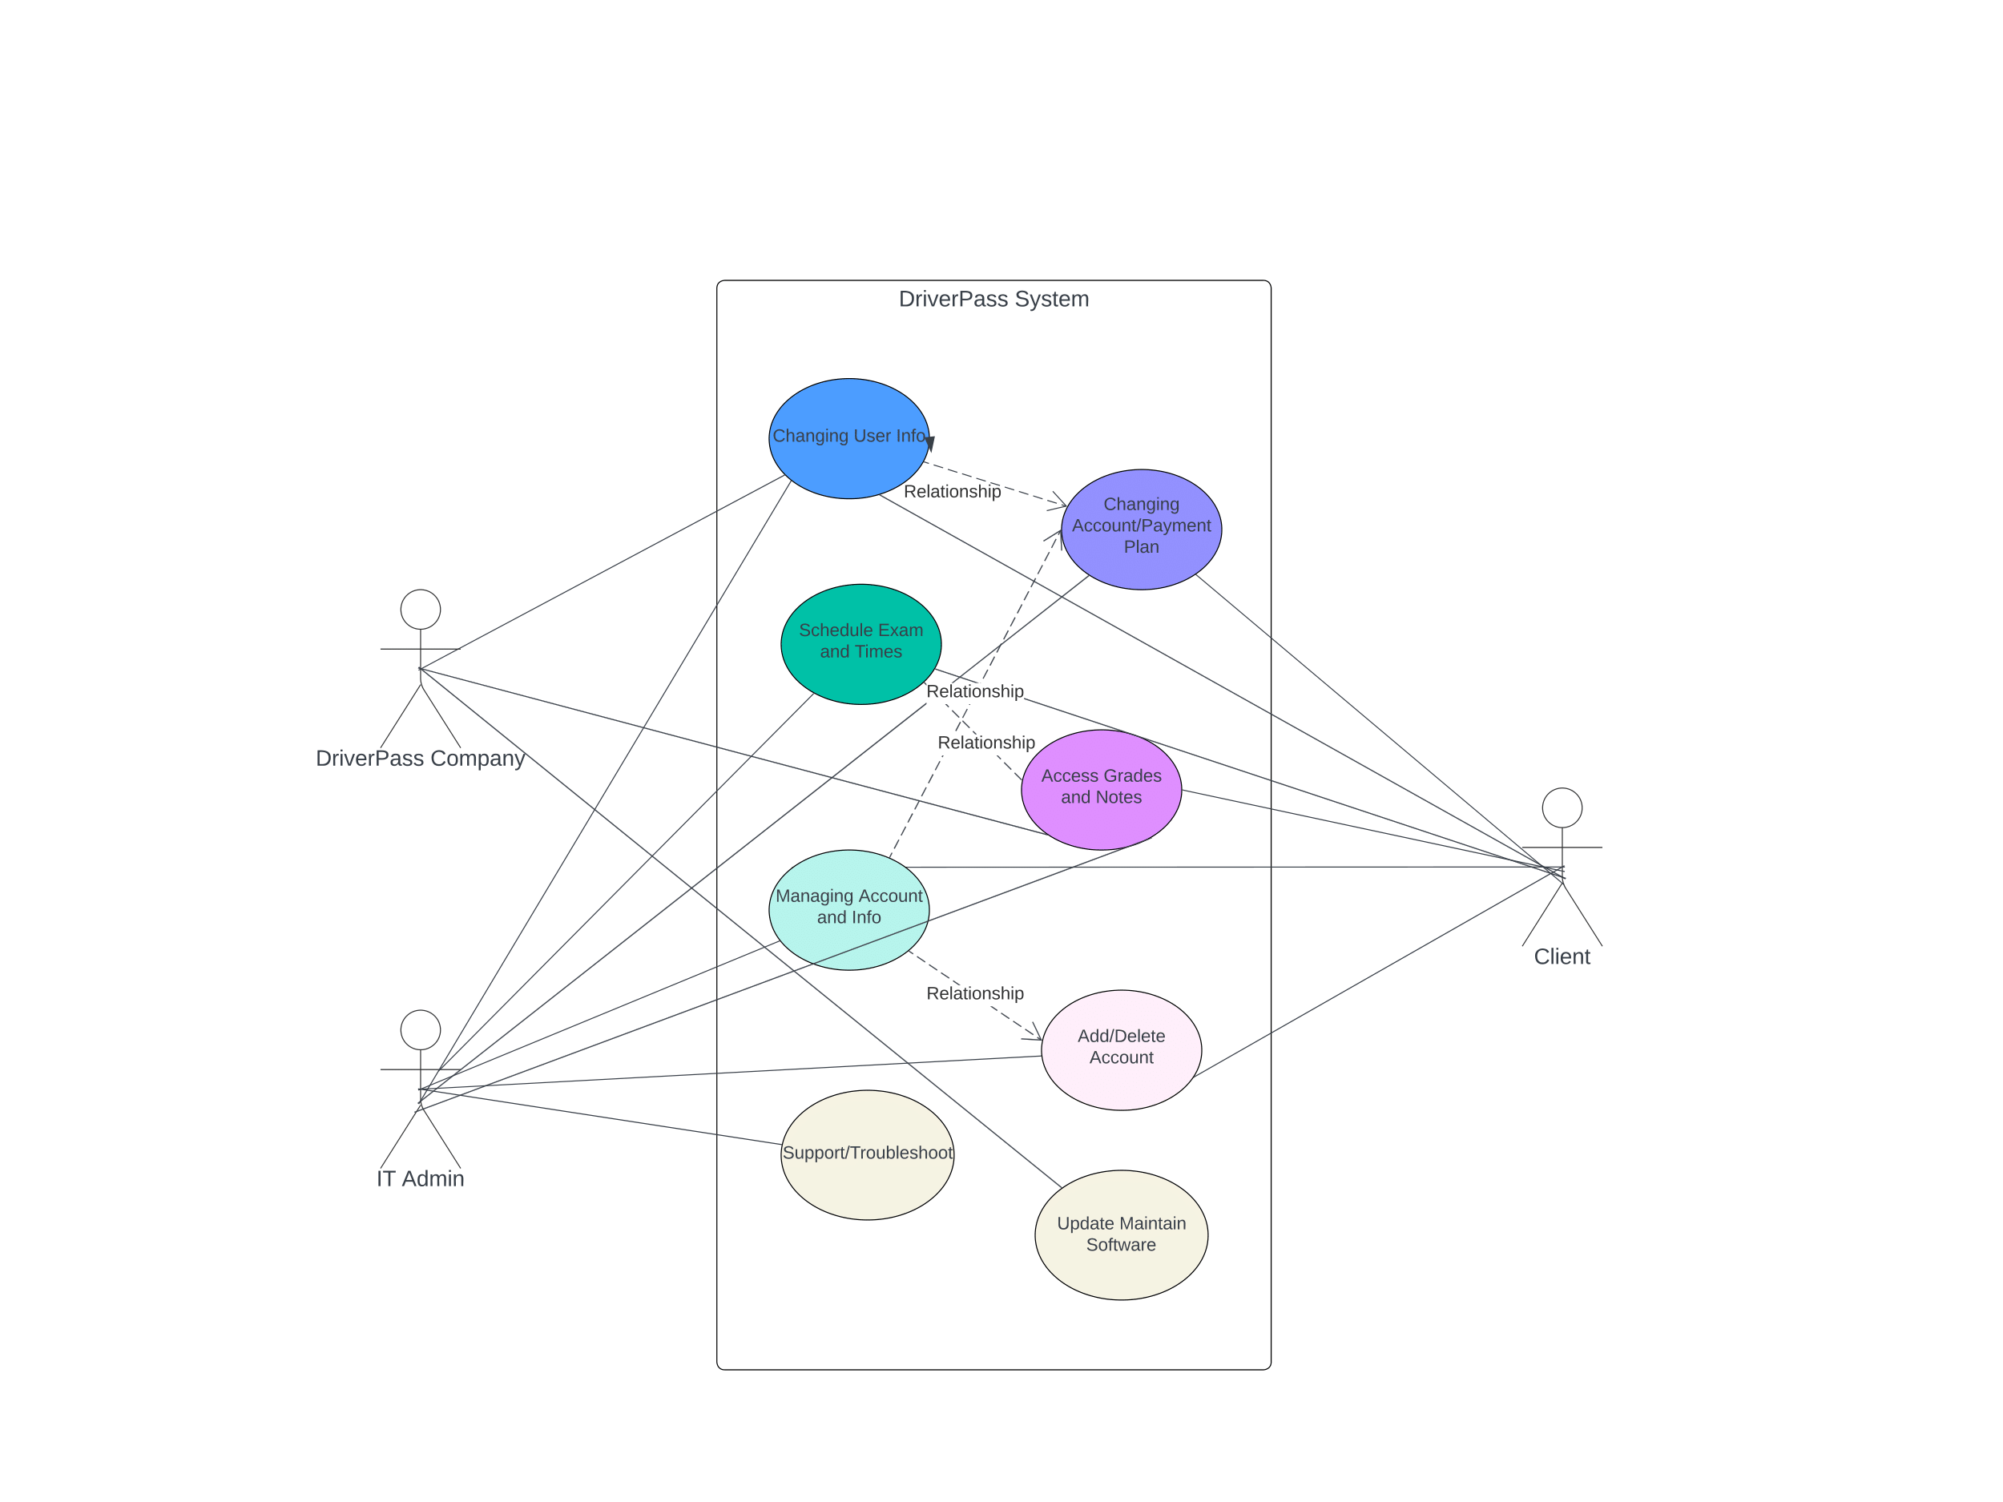

### UML Activity Diagrams

*[You were asked to choose* ***two*** *use cases and create* ***two*** *activity diagrams, one for each use case. Please insert* ***both*** *of your activity diagrams here. Check to make sure that you included appropriate components and symbols and that your design meets the client’s needs.]*

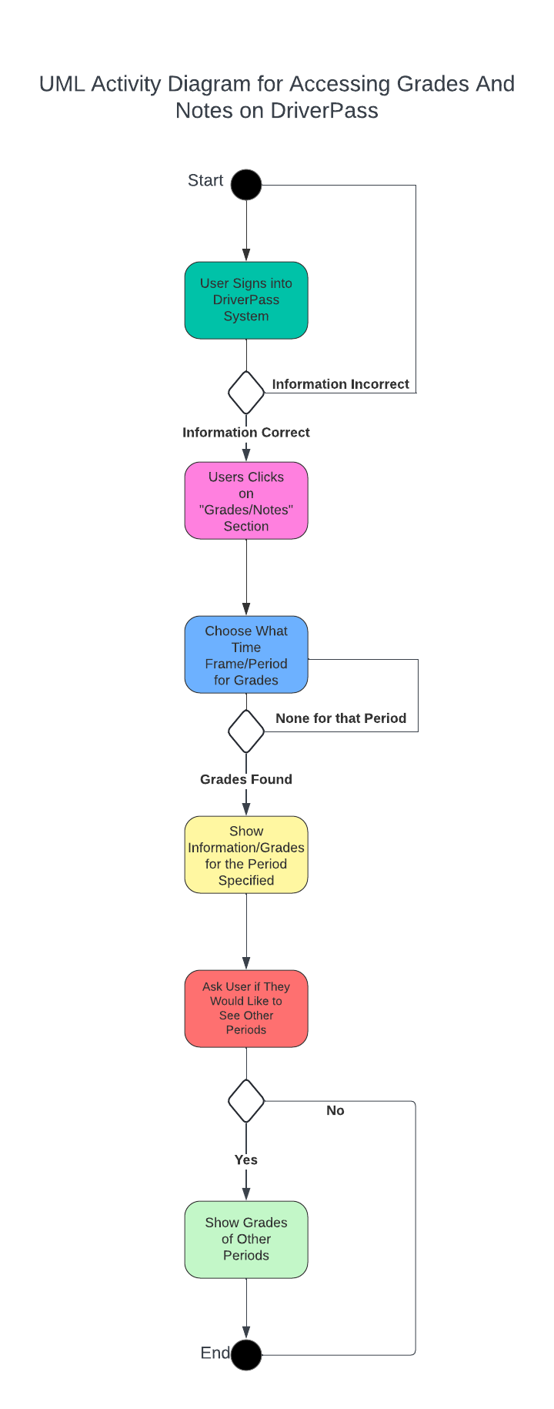

### UML Sequence Diagram

*[You were asked to create a sequence diagram based on* ***one*** *of the use cases you chose. Please insert your sequence diagram here. Check to make sure that you included appropriate components and symbols and that your design meets the client’s needs.]*

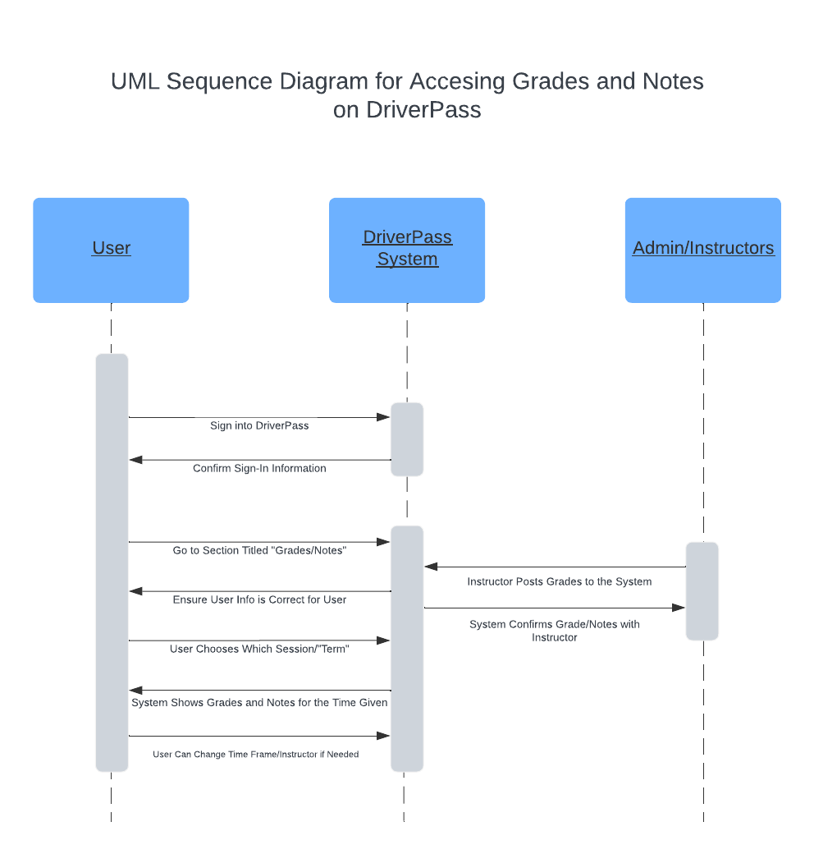

### UML Class Diagram

*[You were asked to create a class diagram based on the different classes and attributes needed for your system design. You are* ***not*** *required to include methods, but you may if you wish. Please insert your class diagram here. Check to make sure that you included appropriate components and symbols and that your design meets the client’s requirements.]*

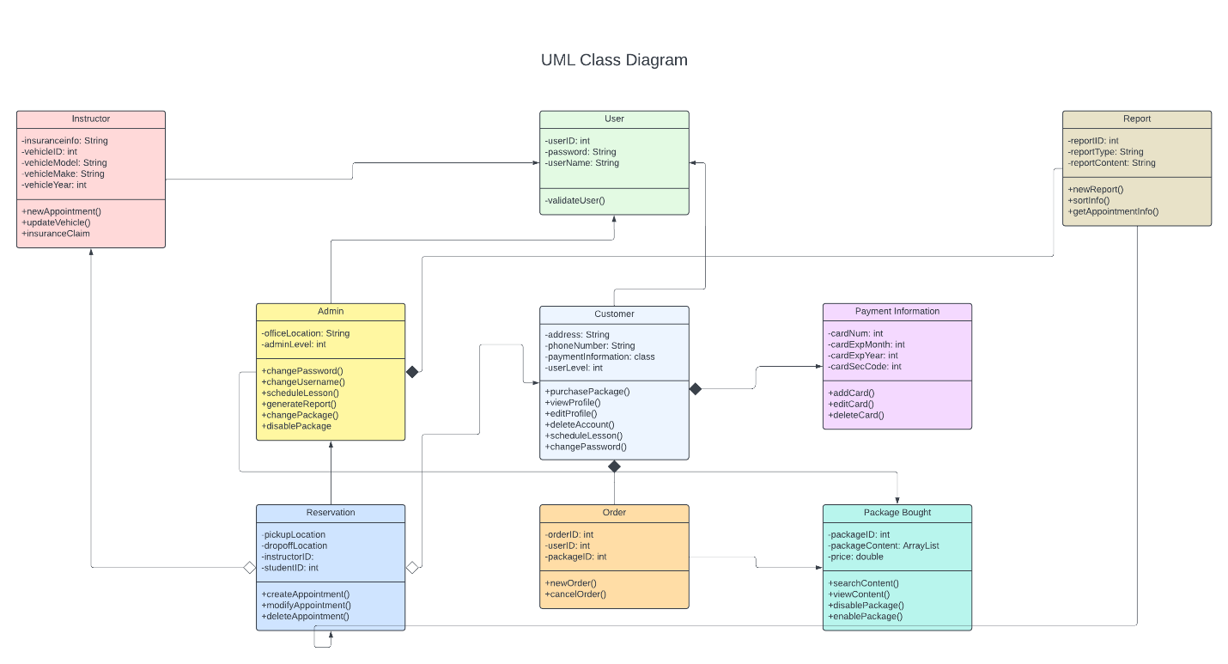

## Technical Requirements

*[Based on the diagrams you have created, describe the technical requirements of your system. These requirements should address the required hardware, software, tools, and infrastructure necessary for your system design.]*

According to the information seen above, the system for both the client and host will need to be reliable and secure. DriverPass will need to ensure that they have the technical requirements to uphold this system. For this type of necessity, DriverPass needs to have a good cloud data storage system, a solid memory system, a reliable internet connection that is continuously stable and secure, critical security measurements due to valuable information, adaptability and scaling power, and a great customer support system. Since DriverPass will be offering this to many different time zones and people, ensuring that the system is always running as it should be very important. As far as nonfunctional requirements are concerned, the list is just as important. First, a user and IT admin must have full control over one’s information and database. It also needs to be run smoothly across all browsers and operating systems. Next, changing of information should only refactor the code, not change it. Lastly, there needs to be many tools installed for secure coding, secure communications, and other improvements to the code and backend. Doing all of this will only strengthen the backend and functional requirements, but also add to the experience of DriverPass’s system.